A CASE STUDY REPORT ON
CARE CIRCLE - ELDERLY CHECK IN COORDINATION SYSTEM
SUBMITTED TO
Artificial Intelligence and Data science

As a part of fulfillment of CIE I Exam of Subject: Software Engineering

By
Sanika Chowdhary 36016
Shravani Dhadge 36019
Pranjali Giri 36026

Under the guidance of

Mrs. Rucha Shaiva


P.E.S’s MODERN COLLEGE OF ENGINEERING,
SHIVAJINAGAR, PUNE 05
(An Autonomous Institute Affiliated to Savitribai Phule Pune University)
2026-27

CERTIFICATE
This is to certify Ms. Sanika Chowdhary, Shravani Dhadge , Pranjali Giri , Roll No. 36016, 36019, 36026 of T.Y. B.Tech. A Division, has successfully completed the case study entitled “ CareCircle - Elderly check in coordination system ” as a bonafide work carried out in partial fulfillment of the requirements for the CIE-I Examination of the course Software Engineering (ADS01303) , prescribed under the T.Y. B.Tech. 2024 Pattern, during the academic year 2026–2027, Semester V.
The work presented in this case study is found to be satisfactory and fulfills the academic requirements prescribed for the course.

Mrs. Rucha Shaiva Prof.Dr.Mrs.Shraddha.V.Pandit Subject Incharge HoD

Place: Pune
Date: 22/8/2026

CONTENTS

Chapter No. | Name of Chapter | Page Number
1 | Problem Understanding | 6
2 | Stakeholder Identification | 12
3 | Software Characteristics | 13
4 | Software Process Model Selection | 15
5 | Requirement Traceability Matrix | 19
6 | Requirement Modeling | 22
7 | Conclusion | 37

List of Tables
Table Number | Table/Figure Title | Page Number
Table 2.1 | Stakeholder Analysis and Role Responsibilities | 12
Table 4.5 | Comparison of all the models | 16
Table 5.1 | Requirement Traceability Matrix for CareCircle | 19
Table 5.2 | Requirement ID Classification | 20
Table 6.3 | Actor and Use Case Mapping | 29
Table 6.3.1 | Use Case 1: User Registration/Login | 29
Table 6.3.2 | Use Case 2: Schedule Check-In | 30
Table 6.3.3 | Use Case 3: Perform Check-In | 31
Table 6.3.4 | Use Case 4: Handle Missed Check-In | 32
Table 6.3.5 | Use Case 5: View Check-In History | 33
Table 6.4.2 | Class Responsibilities | 35
Table 6.4.3 | Class Relationships | 36

List of figures

Figure Number | Figure Title | Page Number
Figure 1.1 | Existing System Workflow | 7
Figure 1.2 | Proposed CareCircle System Workflow | 9
Figure 5.2 | Requirement Traceability Flow | 21
Figure 6.1 | ER Diagram of CareCircle | 23
Figure 6.2.1 | Context-Free Diagram of CareCircle | 25
Figure 6.2.2 | DFD Level 0 of CareCircle | 26
Figure 6.2.3 | DFD Level 1 – Check-In Management | 27
Figure 6.3 | Use case diagram of CareCircle | 28
Figure 6.4.1 | Analysis class diagram of Carecircle | 34

1. Problem Understanding

1.1 Problem Statement
The CareCircle - Elderly Check-In Coordination System is designed to resolve the issue related to the necessity to regularly monitor the well-being and security of the elderly individuals, particularly, when it comes to those individuals who live alone and whose relatives are not able to monitor their condition regularly.
As it happens quite often, young family members do not live together with their elderly parents, grandparents, etc., and have no time or ability to keep in touch with them due to their working schedule or residence in other cities. Therefore, the lack of contact may pass unnoticed and there is no simple way to coordinate check-ins of the elderly people by their relatives, friends, neighbors, or caregivers.
Thus, the CareCircle project is intended to provide a special centralized software system for scheduling and tracking of the check-ins. In case if a check-in is missed, the system will notify the required contact person so that he or she would be able to deal with the situation.
The central issue here is the lack of a proper and organized system for scheduling and responding to missed check-ins of elderly individuals.

1.2 Existing System
In the current scenario, elderly check-ins are done via telephone calls, WhatsApp messages, physical visits, and coordination among the family, relatives, and neighbours. There is no standard method for organizing and recording the process.

Existing Workflow
- Plan Check-in - A member from the family plans when to visit the elderly individual.
- Contact - He/She makes the contact by calling or visiting the individual.
- Verification of Response – The responses and general condition are verified.
- Manual Recording – The details of the check-in process are not usually recorded.
- Follow-Up in Case of No Response – A family member handles the situation in case there is no response.
- Call Backup - A relative or neighbour is called in case of need.
- Informal Coordination – The duties are coordinated through separate calls and messages.
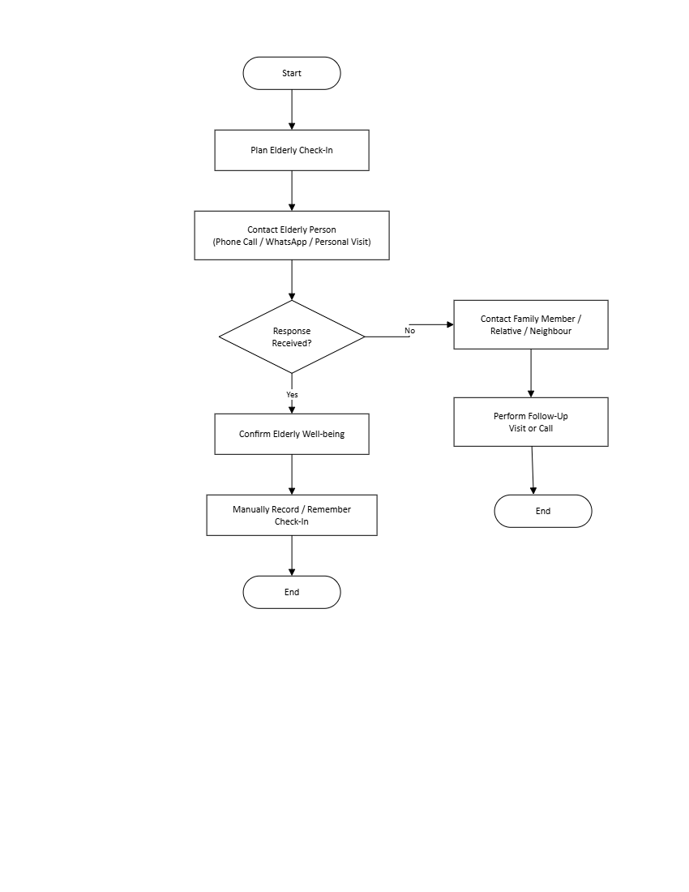

Figure 1.1: Existing System Workflow
1.3 Limitations of Existing System
- Manual process – Check-ins depend on people remembering to make calls or messages.
- No central tracking – There is no single place to view check-in status and history.
- Missed check-ins – A missed response can easily go unnoticed.
- Unclear responsibility – It may be difficult to know who should perform the next check-in.
- Scattered communication – Updates are spread across calls, messages, and personal conversations.
- No automatic follow-up – Relatives or neighbours must be contacted manually when a check-in is missed.

Limited visibility – Family members cannot quickly see the overall check-in status.

1.4 Proposed System
CareCircle is a web based application designed to coordinate the check-in of the elderly by their families. Families can organize, monitor and manage the check-ins of elderly members in one place through CareCircle.
Solution:
- User Registration – All users including elderly, family members and caretakers can create their secured account.
- Schedule Check-in – Daily/weekly check-ins can be pre-scheduled.
- One-Tap Check-in – The senior user can confirm their safety with a tap on the web application.
- Automated Reminders - Reminders will be sent to you on the day the check-in is due.
- No Response to Check-in Notification – If no response is received, an automatic notification will be sent to the designated family member.
- Dashboard for Everyone – Families can see real-time status and check-in history from one dashboard.
- Roles Based Access – Different roles provide different access.

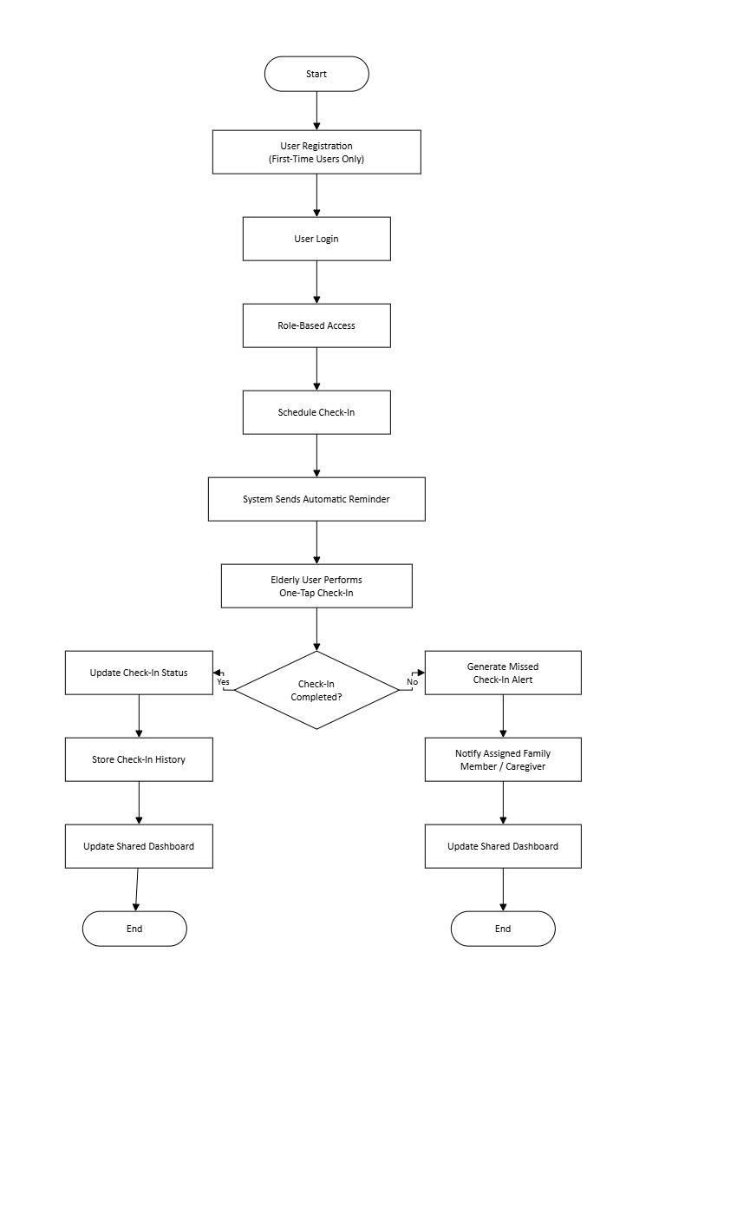

Figure 1.2: Proposed CareCircle System Workflow

1.5 Objectives
The objectives of the web-based elderly check-in coordination system CareCircle are as follows:
- Coordinate the elderly people’s check-ins using the web application.
- Provide an easy way for the elderly users to perform check-in procedures.
- Use automated reminders and notifications in case of missing the check-ins in order to minimize the dependence on the memory.
- Allocate and coordinate the roles of the family members, relatives, and caregivers.
- Maintain the check-in records for further analysis.
- Have a common dashboard to see the information about the pending, accomplished, and missed check-ins.
- Improve the coordination and communication between elderly users and their contacts.
- Perform a quick follow up if the scheduled check-in is missed.

1.6 Scope
The CareCircle project aims to develop a web-based elderly check-in coordination system to help elderly users to stay in touch with their family members, relatives or trusted caregivers. Users will have a simple interface to schedule check-ins, receive reminders, confirm check-ins and keep track of their status. Family members or caregivers are able to view pending, completed, and missed check-ins, get alerts for missed responses, and manage assigned responsibilities. The system will also keep a check-in history and offer an admin module for basic user and system management. The scope is limited to check-in coordination and communication and does not include medical diagnosis, treatment or ongoing health monitoring.

1.7 Assumptions
The following assumptions are taken into consideration in the development of the CareCircle web based system:
- The users access the web application through the internet.
- For older users, check-in can be done on a smartphone, tablet or computer.
- People sign up with correct contact and schedule info.
- Family members or caregivers can respond to missed check-in alerts.
- The elderly user replies in the scheduled time when he is able to.
- The system is for coordination purposes only and not for medical diagnosis or emergency treatment.
- Notifications are successfully delivered when the user has an active internet connection.
- Each older person has at least one trusted contact assigned to follow up.

1.8 Constraints
Potential limitations of the CareCircle project:
- Technical Constraint: System is reliant on internet connectivity, browser compatibility, database availability and a reliable notification system.
- Usability Constraint: The interface should be simple enough for elderly users who may have limited experience of web applications.
- Privacy Constraint: Personal information, contact information, and check-in information should only be accessible to authorized users.
- Operational Constraint The system’s success depends on family members or caregivers responding to missed check-in alerts.
- Financial Constraint: The development and hosting has to be done through free or low cost technologies as an academic project.
- Time Constraint: The system should be developed and tested within the time period of the academic project.
- Scope Constraint: It is limited to check-in coordination and follow-up and is not intended to replace medical or emergency services.

2. Stakeholder Identification

Table 2.1: Stakeholder Analysis and Role Responsibilities

Stakeholder | Type | Role | What They Do | What They Expect
Elderly User | Primary | End User | Performs daily check-ins | Simple and easy-to-use system
Family Member | Primary | Coordinator | Schedules and monitors check-ins | Timely alerts and status updates
Caregiver / Trusted Contact | Primary | Support Contact | Responds to missed check-ins | Clear and accurate notifications
System Administrator | Secondary | System Manager | Manages users and system operations | Secure and reliable system
Project Team / Developers | Project | Development Team | Develops, tests, and maintains the system | Clear requirements and quality software
Project Guide / Evaluator | Project | Reviewer | Reviews project progress and quality | Proper documentation and engineering practices
Hosting / Notification Service | Supporting | Service Provider | Provides hosting and notification services | Stable and reliable operation

3. Software Characteristics

3.1 Nature of Software
CareCircle is a web application/mobile application software which has been created specifically for elderly check-in coordination purposes. This is an application-oriented, user-centered, event-driven, and data-driven application software. The application software takes care of check-in scheduling, check-in status tracking, and alert generation when any planned check-in is missed. It has been created with reliability, maintainability, and usability as its primary characteristics.

3.2 Characteristics of Software
- Easy-to-use: It is designed with a very user-friendly interface.
- Reliable: Keeps track of the accuracy of check-in schedule and status reports.
- Responsive: Gives timely response in case of successful or missed check-ins.
- Secure: Ensures confidentiality of personal and contact details of the users.
- Maintainable: Can be altered according to requirement changes.
- Scalable: Has capability to manage more number of elderly people and their contacts.
- Available: Users can get information about check-ins whenever needed.

3.3 Software Quality Attributes
- Reliability: The system should have the capability to accurately manage check-in scheduling, record the check-ins that have been successfully done and the check-ins that have not been done.
- Security: The user and contact information should not be compromised or accessed by any unwanted party.
- Maintainability: The software should have ease of modification, upgrading and repairing when changes occur.
- Portability: The application should be accessible on various devices and operational environments.
- Performance: The system should have efficient processing time for check-ins, schedules and notifications.
- Scalability: The system should accommodate more and more elderly people and their check-in scheduling.
- Availability: The system should be available whenever users want to check the schedules or reply to notifications.
- Usability: The interface of the software should be easy to use.

3.4 Software Crisis Issues
- Changed requirements: Requirements of users may be changed during the development process, and the system will need modification.
- Reliability problems: Inability to discover a missed check-in and inability to deliver a message in time will reduce the reliability of the system.
- Security threats: Information and contact details of the user should be kept confidential from any uninvolved third party.
- Increased complexity: User management, schedule, check-ins, and messages will increase the complexity of the system.
- Maintenance problems: Software might need updating, bug fixing, and enhancement regularly.
- Performance problems: Delayed processing of schedules and messages will reduce the efficiency of the system.
- Time and financial limitations: Limited time and finances may complicate the development of a reliable system.
- Testing problems: Testing different schedules, check-ins, user actions, and delivery conditions may be difficult.

3.5 Software Myths
Myths are incorrect beliefs about software development that may result in wrong decisions and failure of projects. Below are some of the software myths that are important for the CareCircle system:
1. Customer Myths
- “Simple requirements don’t need details.” Even basic check-in software needs clear rules for scheduling, missed check-ins, and notifications.
- “Requirements can change anytime without impact.” Changes can affect design, development, time, and cost.

2. Developer Myths
- “Working software means development is finished.” CareCircle still needs testing, maintenance, and security updates.
- “More features mean better quality.” Extra features can increase complexity and usability issues.
3. Manager Myths
- “Adding more developers will speed up development.” New developers need time to understand the existing system and code.
- “A simple application will be completed quickly.” Even simple projects require proper planning, testing, and maintenance.

4. Software Process Model Selection

4.1 Selected Process Model
For the CareCircle - Elderly Check-In Coordination System, the model to be used as an SDLC model is the Agile Software Development Model.
The Agile Software Development Model has several benefits like being flexible, doing continuous testing, giving feedback frequently, and delivering working software early.

4.2 Justification
The Agile Model will be used in developing the CareCircle application because:
- Requirement changes: The requirement may vary depending on the feedback from the elderly people, families, and caregivers.
- Incremental development: The different parts of the system like the registration feature, appointment scheduling, alert system, and status tracking can be developed in different iterations.
- Continuous testing: The testing of the application parts will help in fixing errors in the process of development.
- Feedback: The feedback will ensure that the application is user-friendly.
- Early delivery: It enables an early development and delivery of a workable part of the system while developing the whole system.
- Maintenance: Addition of new parts to the application and modification of already existing parts will not necessitate the redesigning of the whole application.
Thus, the Agile model is necessary for development of the CareCircle application.

4.3 Advantages
- Flexibility
- Early delivery of working software
- Continuous testing
- Regular user feedback
- Reduced development risk
- Easy maintenance
- Faster response to changing requirements
- Incremental development

4.4 Limitations
- Requires continuous user involvement
- Frequent requirement changes can affect the project
- Requires effective team communication
- Less predictable cost and schedule
- Requires regular testing and reviews
- Documentation may receive less emphasis
- Not ideal if requirements are completely fixed

4.5 Comparison with Other Models
Table 4.5: Comparison of all models
Process Model | Advantages | Limitations | Suitability for CareCircle
Waterfall | Simple and structured | Difficult to accommodate changes | Low
Incremental | Delivers features in parts | Requires proper planning of increments | High
Iterative | Allows continuous improvement | May require repeated development | High
Evolutionary | Adapts to changing requirements | Can become difficult to manage | High
Concurrent | Supports parallel activities | More complex to coordinate | Moderate
Agile | Flexible, user-focused, and supports frequent feedback | Requires continuous collaboration | Very High
The Agile model is the most suitable for CareCircle because it supports changing requirements, continuous feedback, incremental development, and regular testing.

4.6. Software Requirement Specification (SRS)
A] Functional Requirements
- Registration and Login
- Management of Elderly Users
- Management of family members/caregivers/contacts
- Scheduling of check-ins
- Recording of check-ins
- Detection of missed check-ins
- Notification to designated contacts
- Check-in History Reports
- Users and system settings management
B] Non-Functional Requirements
- Performance: The system needs to respond promptly to user actions and notifications.
- Security: Information about users and contacts should be secure from unauthorized access.
- Reliability: The system should correctly record check-ins and detect any missed check-ins.
- Availability: The system should be accessible any time users want to get check-in information.
- Usability: The interface needs to be clear.
- Maintainability: The system should be easily modifiable.
- Scalability: The system can accommodate more and more users/check-ins.
- Portability: The application needs to be able to operate on the supported hardware and software.
C] External Interface Requirements
- User Interface: Simple interface to perform registration, scheduling, check-ins, notifications and reporting.
- Hardware Interface: Compatibility with computers, smartphones and other supported devices.
- Software Interface: Database system and notification services for information storage and communication.
- Communication Interface: Network/internet connection for information exchange between users and system.
D] System Features
- Users Management: Allows authorized users to register, login and manage their profiles.
- Check-in Scheduling: Allows contacts to schedule check-ins.
- Check-in Management: Allows elderly users or designated contacts to record performed check-ins.
- Missed Check-In Detection: Detects check-ins that were not done according to schedule.
- Notifications: Sends alerts to designated contacts if a check-in was missed.
- Reports: Check-in history reports.
- Error Handling: Displays appropriate messages for invalid input, operation or system failure.
E] Data Requirements
- Database Requirements: Database should contain user, contacts, schedule, check-in and notification information.
- Data Entities: User, Elderly Person, Contact, Check-In Schedule, Check-In Record, Notification.
- Data Storage: Data needs to be stored in a systematic manner and accessed when needed.
- Data Validation: User inputs and check-in data needs to be validated before storing.
- Data Security: Data needs to be protected from unauthorized access and modification.

5. Requirement Traceability Matrix (RTM)
The Requirement Traceability Matrix (RTM) is employed to define a linkage between the goals of the CareCircle software and its software requirements. The purpose of RTM is to ensure that each significant goal of the proposed system has at least one software requirement that represents it.

5.1 Requirement Traceability Matrix
Table 5.1: Requirement Traceability Matrix for CareCircle
Business Objective ID | Business Objective | Requirement ID | Software Requirement | Verification
BO-01 | Keep elderly check-ins happening on a regular basis | FR-01 | Family members or caregivers should be able to set up check-in schedules | Functional Testing
BO-02 | Make checking in effortless for the elderly user | FR-02 | The elderly user should be able to confirm a check-in with just a simple action | Functional Testing
BO-03 | Cut down on missed check-ins | FR-03 | The system should send a reminder automatically before each scheduled check-in | Functional Testing
BO-04 | Make sure follow-up happens quickly when needed | FR-04 | If a check-in is missed, the system should raise an alert | Functional Testing
BO-05 | Keep responsibilities clearly assigned | FR-05 | Family members or caregivers should be able to be assigned as responsible for specific check-ins | Functional Testing
BO-06 | Keep a record of past check-ins | FR-06 | The system should store records of completed, pending, and missed check-ins | Database Testing
BO-07 | Give everyone a central place to monitor things | FR-07 | A dashboard should show check-in status and history at a glance | System Testing
BO-08 | Keep user data safe | FR-08 | Access to the system should be role-based, limited to authorized users | Security Testing
BO-09 | Make the system easy to use | FR-09 | The interface should be simple and user-friendly | Usability Testing
BO-10 | Keep the system dependable | FR-10 | Check-in data should be stored and retrieved reliably | Reliability Testing
Table 5.2: Requirement ID Classification
Requirement Type | Requirement IDs | Description
Functional Requirement | FR-01 to FR-07 | Covers what the CareCircle system is actually supposed to do
Non-Functional Requirement | NFR-01 to NFR-03 | Covers how well the system needs to perform — quality and operational aspects

5.2 Traceability Flow
Traceability Linkages can be illustrated as follows:
Business Objectives → Software Requirements → System Features → Verification/Testing
E.g.
Prompt follow up → FR-04 → Missed Check-In Alert → Functional Testing
This way each of the main objectives of CareCircle is testable via relevant system features.
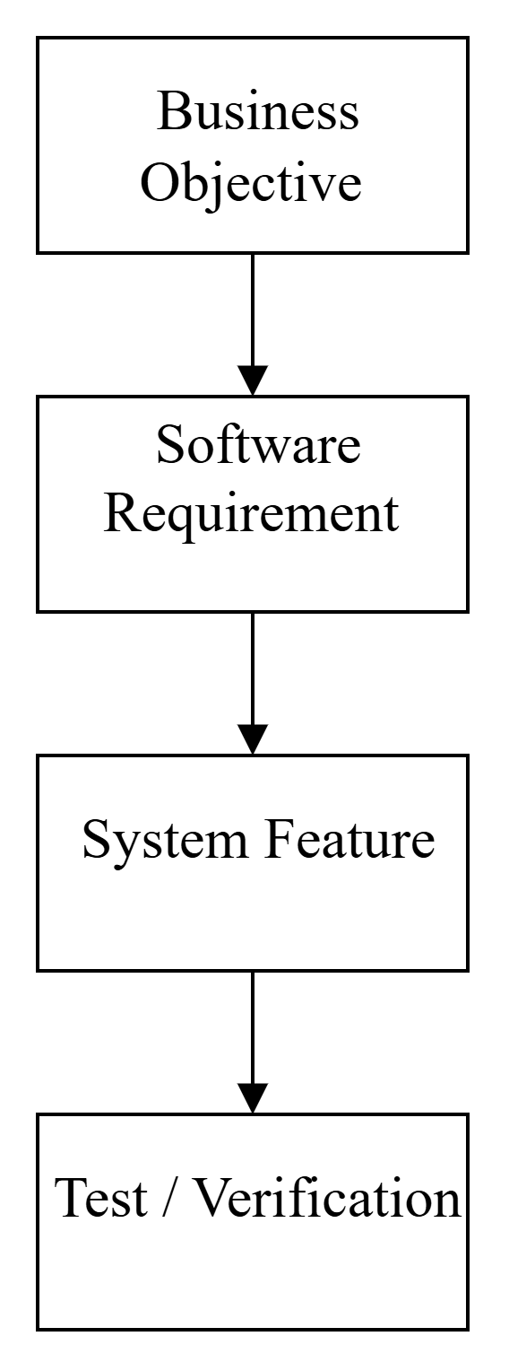
Figure 5.2: Requirement Traceability Flow

6. Requirement Modeling
Requirement modeling is a technique where the system CareCircle can be modeled through various software engineering models. Such models offer insight into the data, process, user, interaction, and software classes of the system.
Below are some of the models for CareCircle:
- ER Diagram
- Data Flow Diagram
- Scenario-based Modeling
- Use Case Diagram
- Class-based Modeling

6.1 Draw ER Diagram for proposed system
The Entity-Relationship (ER) diagram shows the main entities of the CareCircle system and the relationship among them.
Main Entities:
- User – holds data about the users of the system.
- ElderlyUser – represents elderly users of the system.
- TrustedContact – represents family members/relatives or caregivers who are accountable for follow-ups.
- CheckIn – holds scheduled and completed check-in data.
- Notification – holds reminder and missed check-in alert data.
- Admin – performs management of system users.
Main Relationships:
- A user is associated with an elderly user.
- An elderly user may have several check-ins.
- A trusted contact is related to an elderly user.
- A check-in may produce notifications.
- An administrator manages system users.

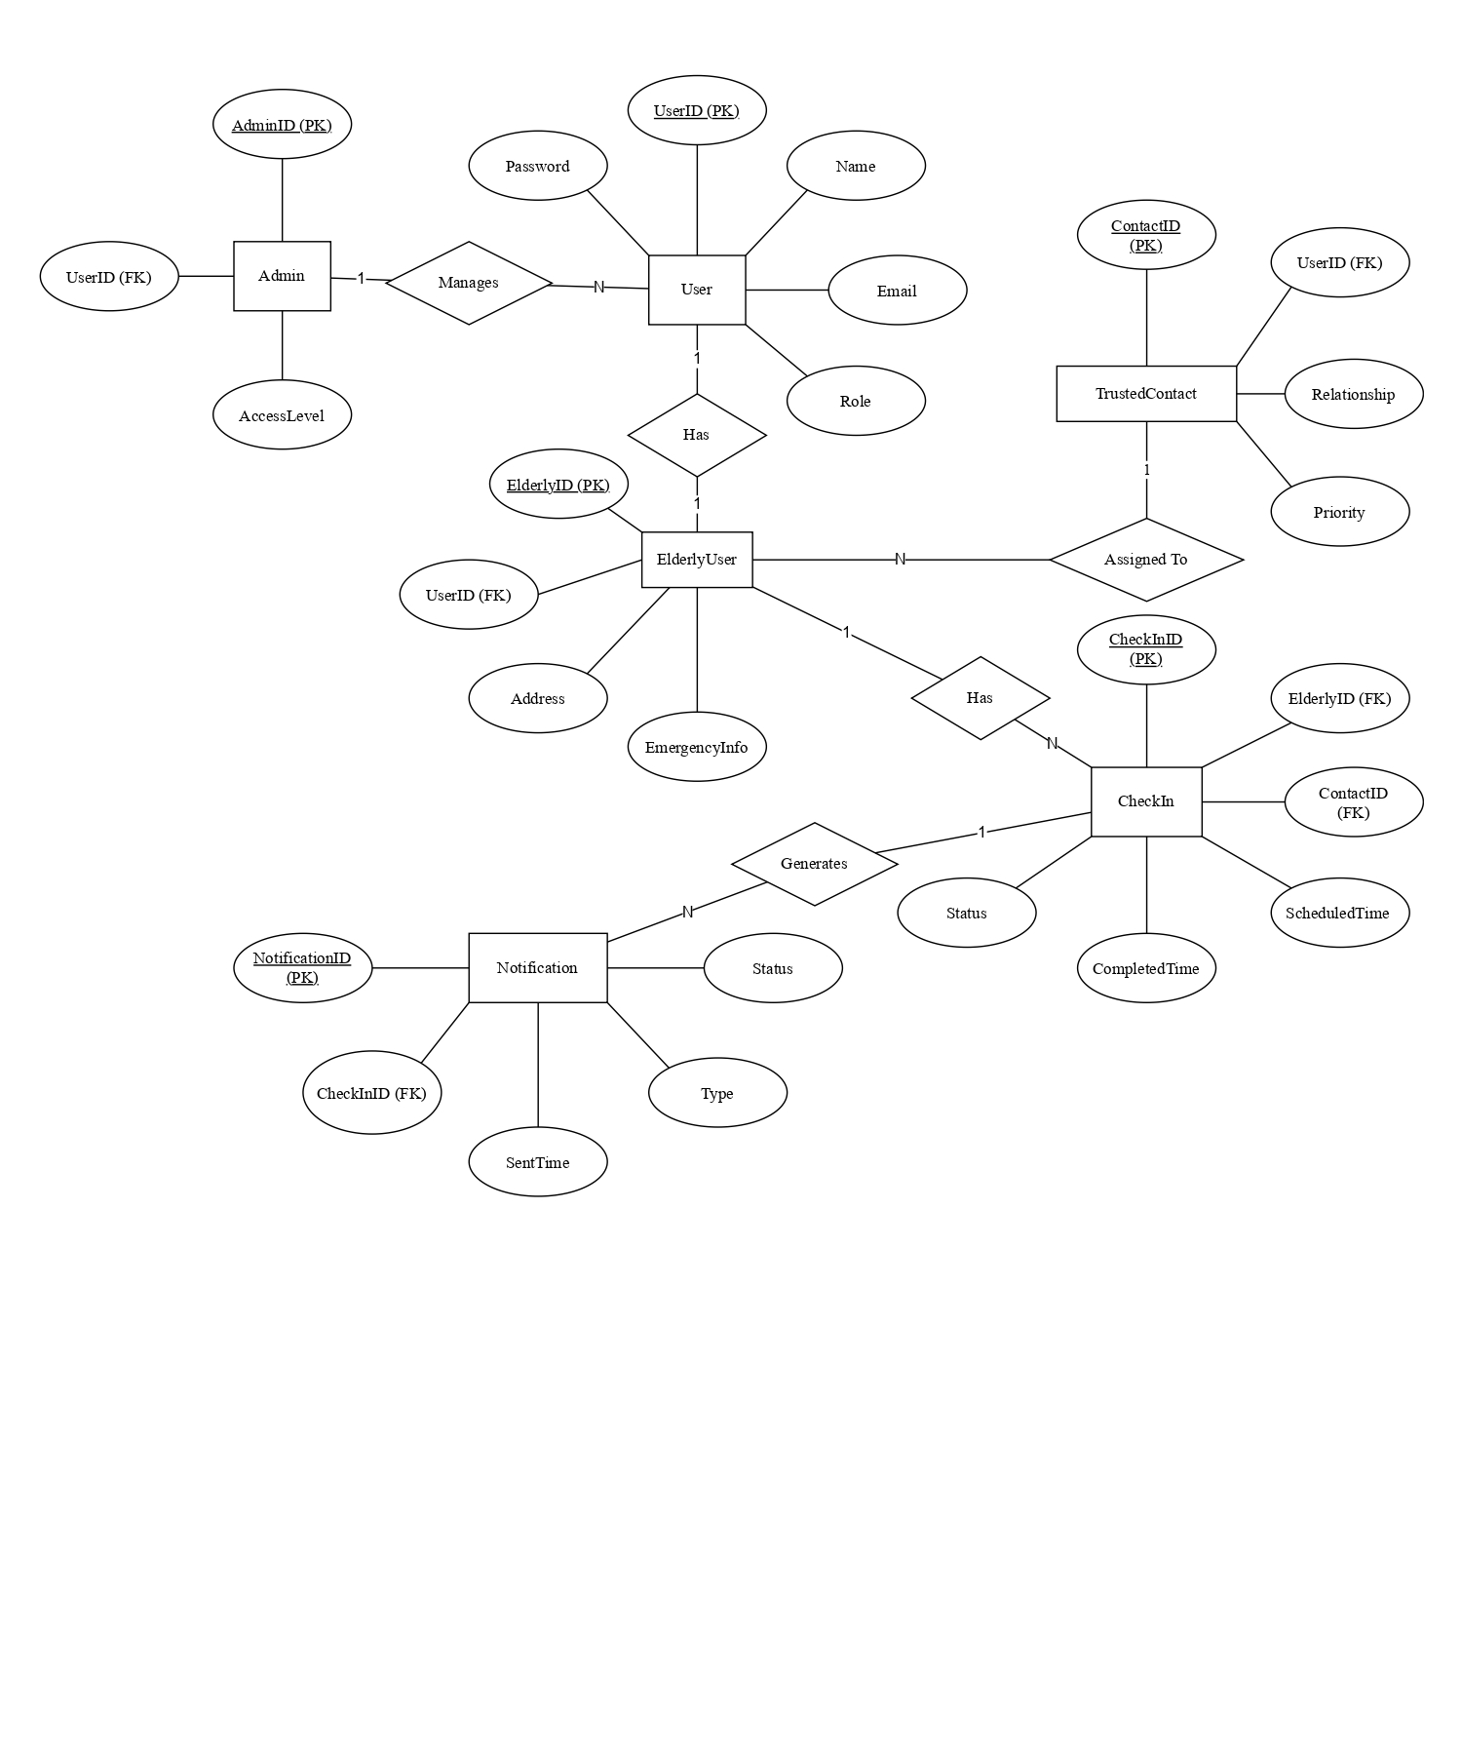

Figure 6.1: ER Diagram of CareCircle

6.2 Draw DFD Diagram for proposed system
A Data Flow Diagram (DFD) represents how information moves between users and the CareCircle system.

6.2.1 Context-Free Diagram

The Context Diagram represents CareCircle as a single system and shows its interaction with external entities.

External Entities:

Elderly User

Family Member

Caregiver/Trusted Contact

System Administrator
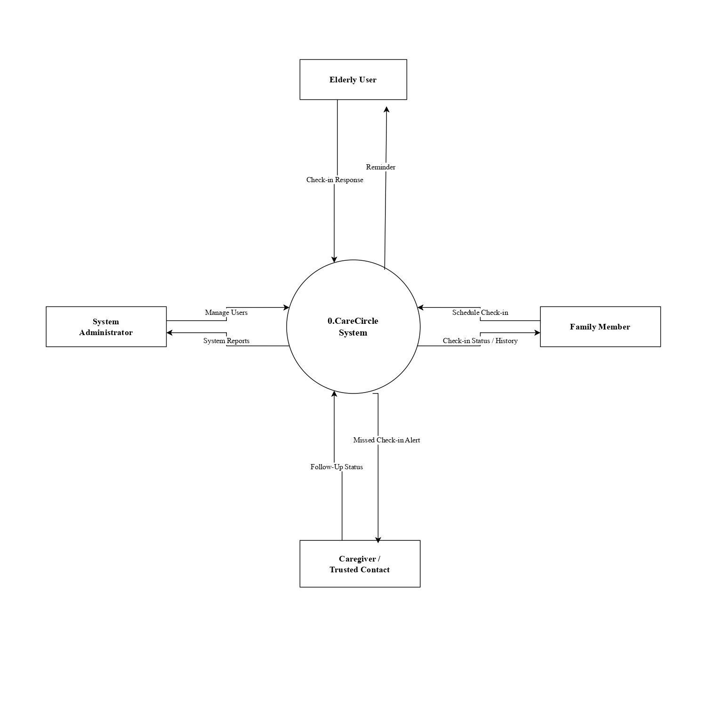
Figure 6.2.1: Context-Free Diagram of CareCircle

6.2.2 DFD Level 0
At Level 0, the CareCircle system is divided into major processes.
Main Processes:
- User Management
- Check-In Management
- Notification Management
- Status and History Management
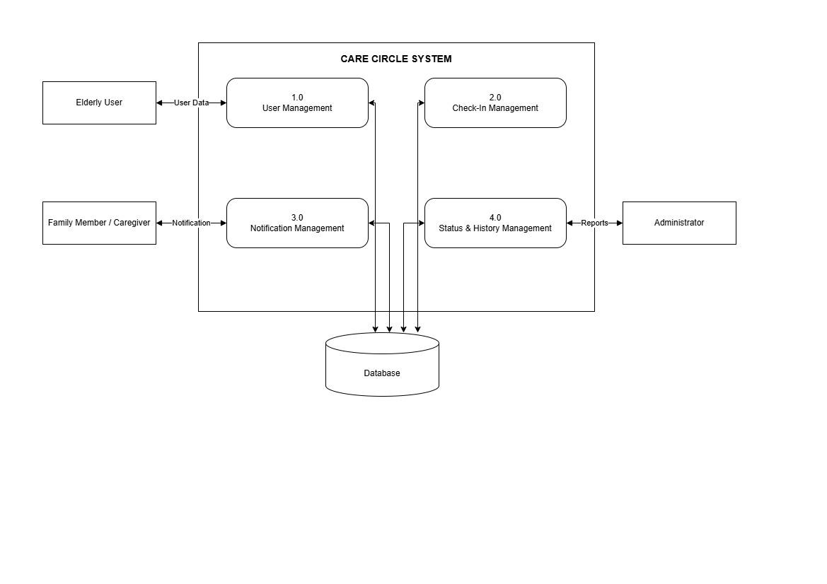

Figure 6.2.2: DFD Level 0 of CareCircle

6.2.3 DFD Level 1
DFD Level 1 gives more detailed information about the Check-In Management process.
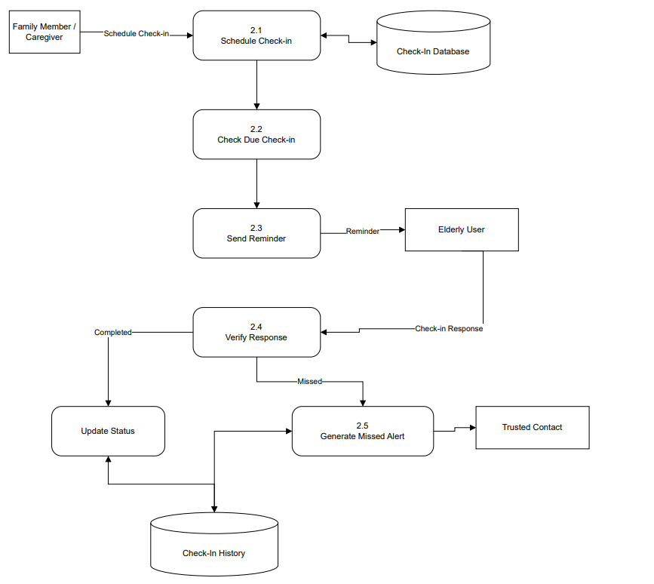

Figure 6.2.3: DFD Level 1 – Check-In Management

6.3 Scenario-Based Modeling
Scenario-based modeling describes how different users interact with the CareCircle system to achieve specific goals.
The major actors are:
- Elderly User
- Family Member
- Caregiver/Trusted Contact
- System Administrator
The major use cases are:
- Register/Login
- Schedule Check-In
- Perform Check-In
- Receive Reminder
- Handle Missed Check-In
- View Check-In History
- Manage Users

Actor–Use Case Relationship
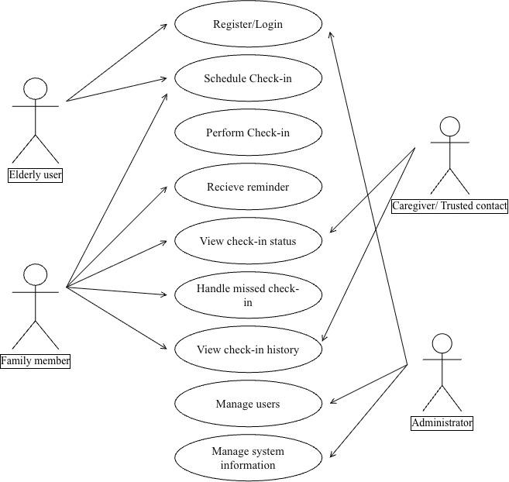

Figure 6.3: Use case diagram of CareCircle

Table 6.3: Actor and Use Case Mapping
Actor | Major Use Cases
Elderly User | Register/Login, Receive Reminder, Perform Check-In
Family Member | Register/Login, Schedule Check-In, View Status, View History, Handle Missed Check-In
Caregiver/Trusted Contact | Register/Login, Schedule Check-In, View Status, Handle Missed Check-In
Administrator | Login, Manage Users, Manage System Information

Use Case Descriptions
A use case description is a short, structured summary of how a user interacts with the system to complete a specific task, including the steps involved and possible alternate outcomes.

Table 6.3.1 : Use Case 1: User Registration/Login
Field | Description
Use Case ID | UC-01
Use Case Name | User Registration/Login
Primary Actor | Elderly User / Family Member / Caregiver
Preconditions | The user has access to the web application.
Postconditions | A user account is created or the user is successfully logged in.
Basic Flow | 1. The user opens the application.  2. The user enters registration/login details.  3. The system validates the details.  4. The system creates the account or authenticates the user.  5. The user is redirected to the appropriate dashboard.
Alternate Flow | If the entered credentials are invalid, the system displays an error message.

Table 6.3.2 : Use Case 2: Schedule Check-In
Field | Description
Use Case ID | UC-02
Use Case Name | Schedule Check-In
Primary Actor | Family Member / Caregiver
Preconditions | The actor is logged in and an elderly user is registered.
Postconditions | A check-in is stored with its date, time, and assigned contact.
Basic Flow | 1. Actor selects an elderly user  2. Actor selects date and time  3. Actor assigns a trusted contact  4. System validates the information  5. The system stores the check-in.
Alternate Flow | If required information is missing, the system asks the actor to provide the missing details.

Table 6.3.3: Use Case 3: Perform Check-In
Field | Description
Use Case ID | UC-03
Use Case Name | Perform Check-In
Primary Actor | Elderly User
Preconditions | A check-in has been scheduled
Postconditions | Check-in status is updated to completed
Basic Flow | 1. Elderly user receives a reminder  2. User opens the application  3. User selects the check-in option  4. System records the response  5. Status is updated as completed
Alternate Flow | If the user does not respond within the specified period, the check-in is marked as missed

Table 6.3.4: Use Case 4: Handle Missed Check-In
Field | Description
Use Case ID | UC-04
Use Case Name | Handle Missed Check-In
Primary Actor | Family Member / Caregiver
Preconditions | A scheduled check-in has not received a response
Postconditions | Trusted contact is notified and follow-up can be performed
Basic Flow | 1. System identifies a missed check-in  2. System generates an alert  3. Assigned contact receives the notification  4. Contact follows up with the elderly user  5. Follow-up information can be recorded
Alternate Flow | If the assigned contact is unavailable, another trusted contact may be contacted manually

Table 6.3.5: Use Case 5: View Check-In History
Field | Description
Use Case ID | UC-05
Use Case Name | View Check-In History
Primary Actor | Family Member / Caregiver
Preconditions | The user is authenticated.
Postconditions | Previous check-in records are displayed
Basic Flow | 1. User opens the dashboard  2. User selects check-in history  3. System retrieves stored records  4. System displays completed, pending, and missed check-ins
Alternate Flow | If no records exist, the system displays an appropriate message

6.4 Class-Based Modeling
Class-based modeling identifies the major software classes required for the CareCircle system. Each class contains relevant attributes and operations.

6.4.1 Analysis Class Diagram
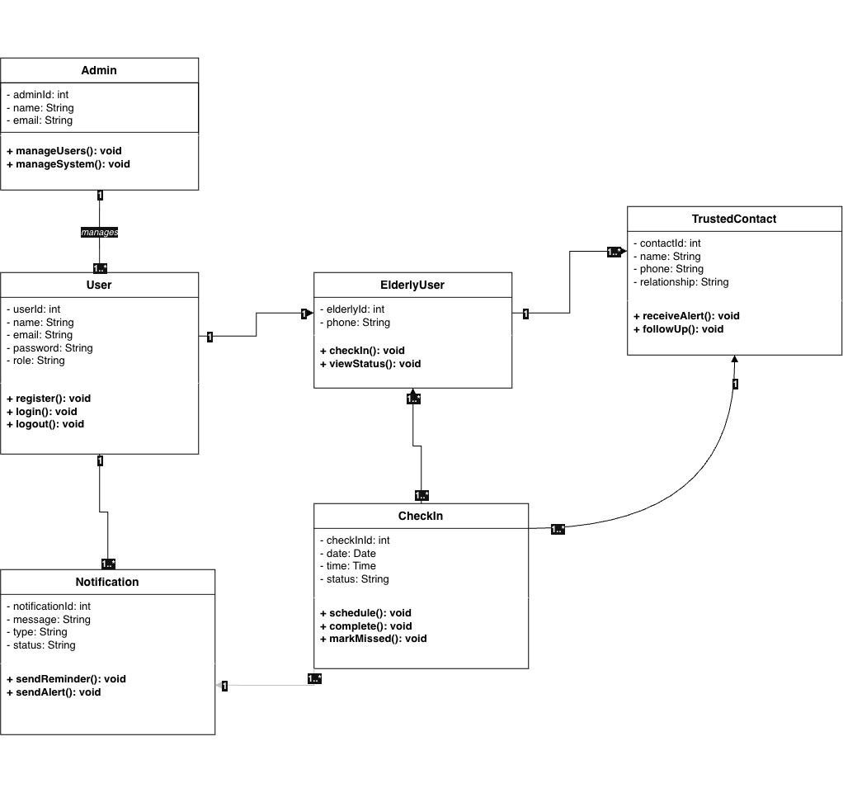

Figure 6.4.1: Analysis class diagram of Carecircle

6.4.2 Class Description:

Table 6.4.2: Class Responsibilities
Class | Main Responsibility
User | Stores common user information and manages authentication
ElderlyUser | Represents the elderly person who performs check-ins
TrustedContact | Represents family members, relatives, or caregivers responsible for follow-up
CheckIn | Stores scheduling, date, time, and status of check-ins
Notification | Handles reminders and missed-check-in alerts
Admin | Performs user and basic system management

6.4.3 Relationship Summary

Table 6.4.3: Class Relationships
Relationship | Description
User – ElderlyUser | An elderly user has a registered user account.
ElderlyUser – CheckIn | An elderly user can have multiple check-ins.
TrustedContact – CheckIn | A trusted contact can be assigned to check-ins.
CheckIn – Notification | A check-in can generate reminders or missed-check-in notifications.
Admin – User | Administrator manages registered users.

7. Conclusion
CareCircle is a web based software solution known as the Elderly Check-In Coordination System and has been developed following the Agile process model. The project uses different Software Engineering techniques such as stakeholder analysis, preparation of SRS, RTM, ER and DFD modeling, use-case and class modeling as well as qualities such as reliability, security, usability, maintainability and scalability.
The system replaces the informal check-ins with scheduled check-ins, reminders, alerts in case of missed check-ins, role-based access, status tracking and check-in history.
Expected Benefits
- Better coordination among elderly users, family members, and trusted contacts.
- We reduce the amount of manual work by using schedules and automated reminders.
- Provide a timely follow-up if a check-in is missed.
- One has clear responsibility towards the members of the family or towards the carers.
- Records should be kept in a central location so that the check-in history and status can be easily tracked.
Future Scope
The CareCircle system can be improved by adding support for mobile apps, introducing multilingual and voice-based check-ins, providing smarter notifications, offering check-in analytics, allowing optional location sharing, and integrating with emergency contacts or caregiving services; it can also be scaled up for use by senior-care organizations and larger caregiver networks.
In summary, CareCircle shows how Software Engineering principles can be put into practice to produce a reliable, user-friendly, and scalable solution for coordinating check-ins for the elderly.

References
[1] S. Lee, M. Ory, D. V. Dahlke, and M. Smith, “Social Connectedness and Communication Technology Among Paid and Unpaid Caregivers of Middle-Aged and Older Adults,” Innovation in Aging, vol. 5, suppl. 1, p. 915, 2021.
[2] J. Müller, X. Zhao, and H. M. Foran, “A Technology-Supported Psychoeducational Intervention for Older Adults and Their Families to Improve Social Isolation, Loneliness, and Intergenerational Connectedness—A Randomized Controlled Study,” Cyberpsychology, Behavior, and Social Networking, vol. 27, no. 11, pp. 835–845, 2024.
[3] R. S. Pressman and B. R. Maxim, Software Engineering: A Practitioner's Approach, 9th ed., McGraw-Hill Education, 2019.
[4] I. Sommerville, Software Engineering, 10th ed., Pearson, 2016.
[5] ISO/IEC/IEEE 29148:2018, Systems and Software Engineering — Life Cycle Processes — Requirements Engineering, International Organization for Standardization, 2018. ISO/IEC/IEEE 29148:2018 – Requirements Engineering
[6] Object Management Group (OMG), Unified Modeling Language (UML) Specification, for UML-based requirement and class modeling. OMG Unified Modeling Language Specification
[7] K. Beck et al., “Manifesto for Agile Software Development,” Agile Alliance, 2001.
[8] ISO/IEC/IEEE 12207:2017, Systems and Software Engineering — Software Life Cycle Processes, International Organization for Standardization, 2017.
[9] ISO/IEC 25010:2023, Systems and Software Engineering — Systems and Software Quality Requirements and Evaluation (SQuaRE) — Product Quality Model, International Organization for Standardization, 2023.
[10] ISO/IEC/IEEE 24748-3:2020, Systems and Software Engineering — Life Cycle Management — Part 3: Guidelines for the Application of ISO/IEC/IEEE 12207, International Organization for Standardization, 2020.
[11] R. S. Pressman and B. R. Maxim, Software Engineering: A Practitioner's Approach, 9th ed., McGraw-Hill Education, 2019.
[12] I. Sommerville, Software Engineering, 10th ed., Pearson, 2016.
[13] J. Nielsen, Usability Engineering, Morgan Kaufmann, 1994.
[14] B. Shneiderman et al., Designing the User Interface: Strategies for Effective Human-Computer Interaction, 6th ed., Pearson, 2016.
[15] W. W. Royce, “Managing the Development of Large Software Systems,” in Proceedings of IEEE WESCON, pp. 1–9, 1970.
[16] M. Fowler and J. Highsmith, “The Agile Manifesto,” Software Development, vol. 9, no. 8, pp. 28–32, 2001.
[17] World Health Organization, Decade of Healthy Ageing: Baseline Report, World Health Organization, Geneva, 2020.
[18] World Health Organization, Global Report on Ageism, World Health Organization, Geneva, 2021.
[19] National Institute of Standards and Technology, Digital Identity Guidelines: Authentication and Lifecycle Management, NIST Special Publication 800-63B, National Institute of Standards and Technology.
[20] OWASP Foundation, OWASP Application Security Verification Standard (ASVS), OWASP Foundation.

